**Project Report**

**1.INTRODUCTION**

**1.1Overview**

**General elections were held in India in seven phases from 11 April to 19 May 2019 to elect the members of the 17th Lok Sabha. Votes were counted and the result was declared on 23 May. The election resulted in a landslide victory for the BJP which won 303 seats and formed the government.**

**1.2Purpose**

**The Lok Sabha has certain powers that make it more powerful than the Rajya Sabha. Motions of no confidence against the government can be introduced and passed in the Lok Sabha. If passed by a majority vote, the Prime Minister and the Council of Ministers resign collectively.**

**2.PROBLEM DEFINITION & DESIGN THINKING**

**2.1 Empathy map**

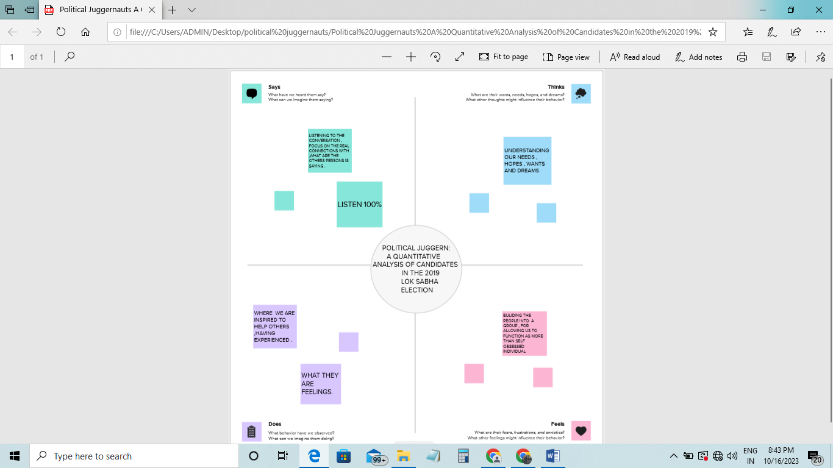

**2.2 Ideation & Brainstorming map**

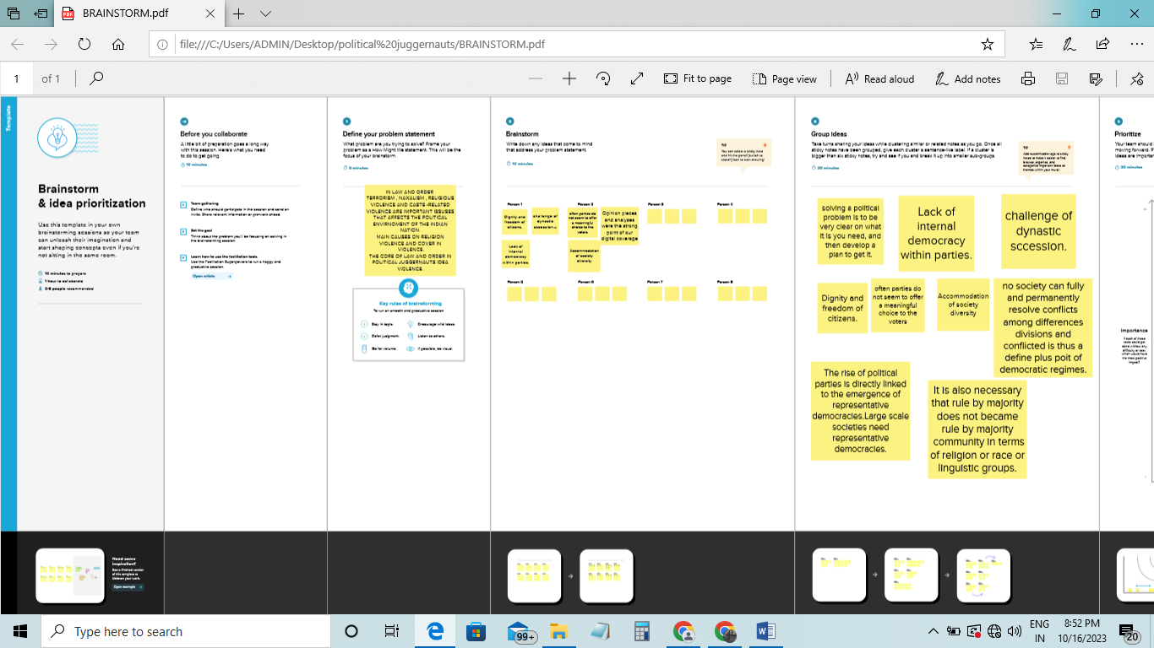

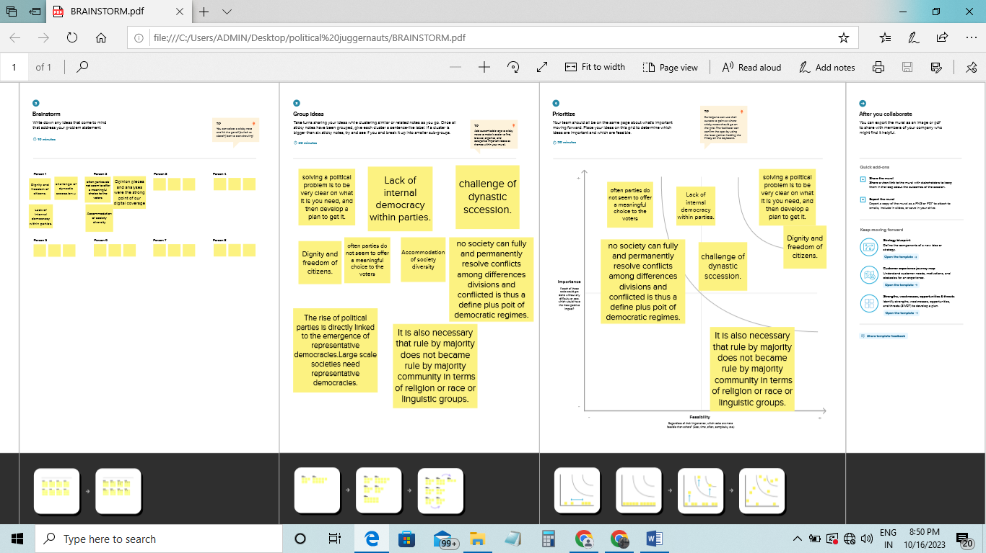

**3. RESULT**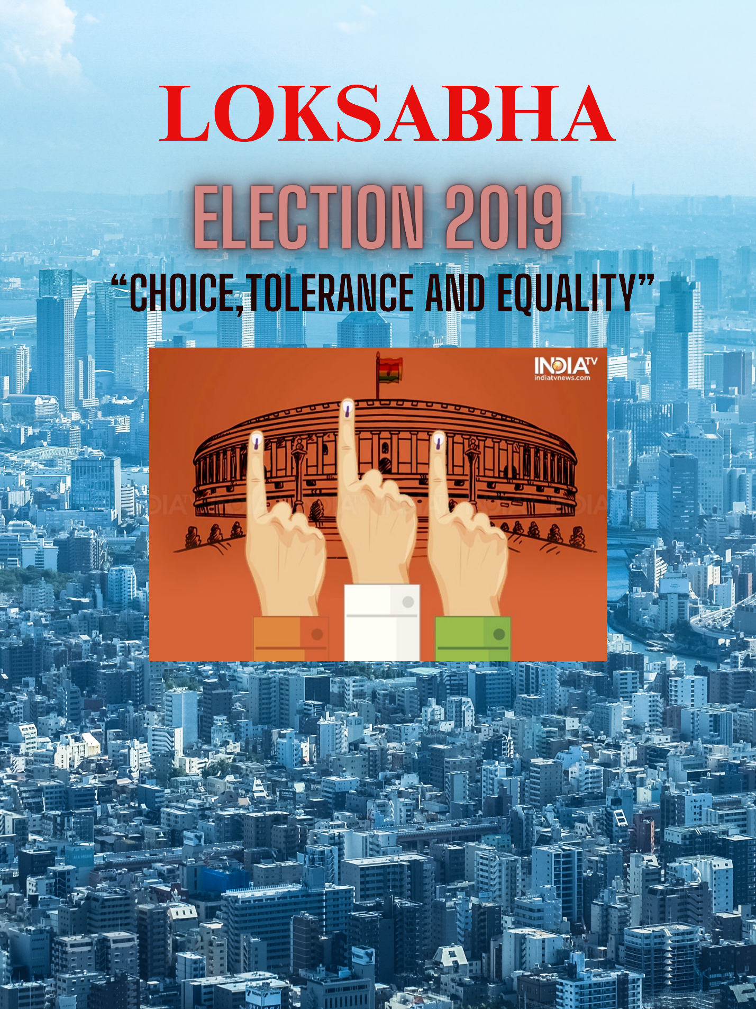

**4. ADVANTAGES & DISAVANTAGES**

**\*Advantages**

* **Its helps in proper functioning of demorcacy through the system of checks and balances.**
* **Money bills can be only introduced in the loksabha.**

**\*Disadvantages**

* **Members of the lok sabha often vote along party lines due to the strong influence of political parties and the whip system.**
* **This can lead to reduced independent thinking and decision making.**

**5. APPLICATIONS**

**People would elect their representatives to the Parliament, then, one group from among these elected representatives forms the government. The Parliament, which is made up of all representatives together, controls and guides the government.**

**6.CONCLUSION**

**It helps us to acquire technical and professional competencies while working on real-world challenges and creating innovative solutions. The program encourages us to think critically and creatively, and it is designed to provide industry-level training at the college level.**